Experiment 7.2
Determination and plotting of Capacitance of an Isolated Sphere vs Radius

Code File Name: Exp7_2_Capacitance_vs_Radius_IsolatedSphere.m
Code
clc;
epsilon0 = 8.854e-12;
R = linspace(0.1,2,100);
C = 4*pi*epsilon0*R;
plot(R,C,'LineWidth',2);
xlabel('Radius (m)');
ylabel('Capacitance (F)');
title('Capacitance of isolated sphere');
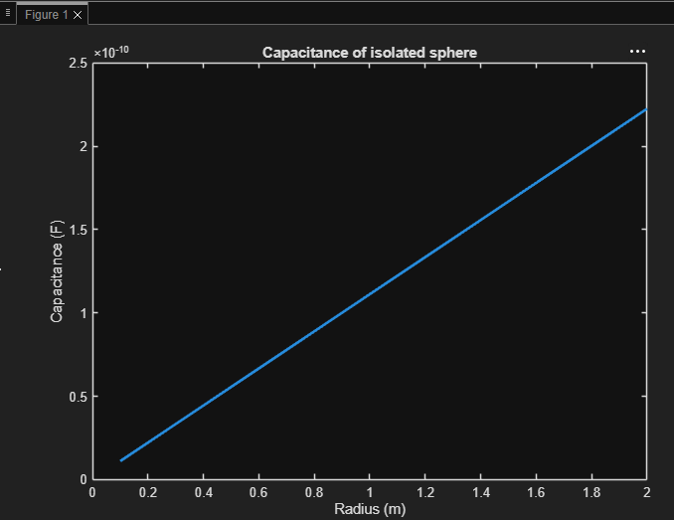
Output Graph

